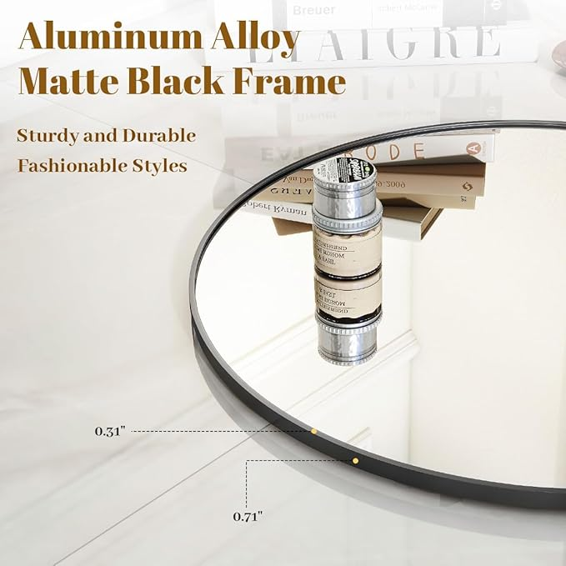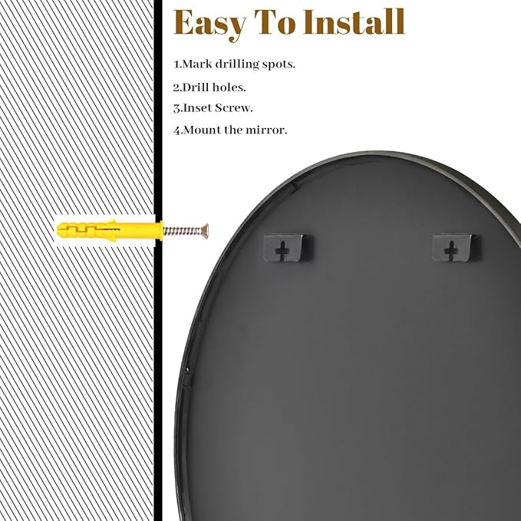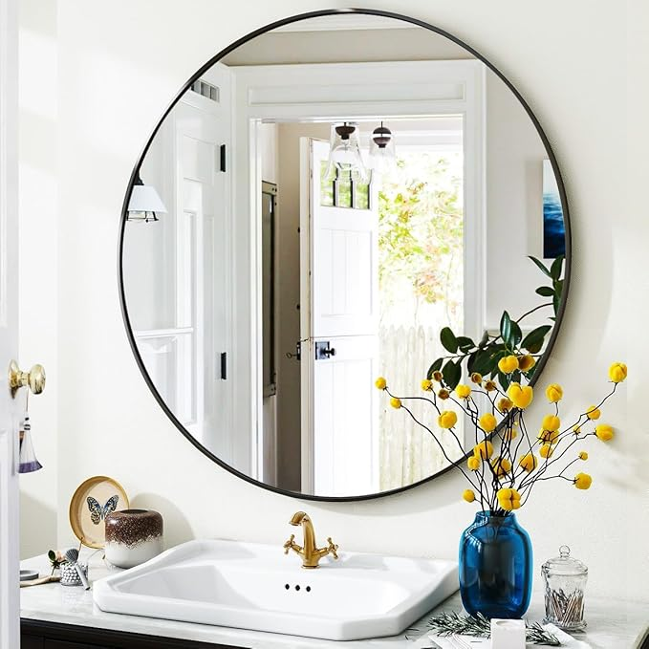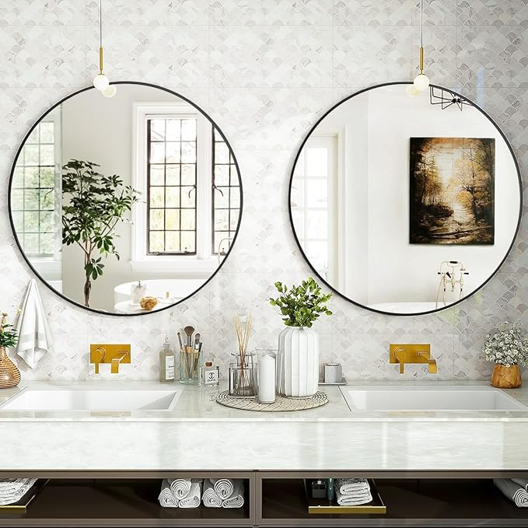

Black Round Bathroom Mirror, 24 inch Circle Wall Mounted Hanging Mirror with Simple Modern Circular Metal Frame for Hallway, Entryway, Living Room, Black Frame

**PRODUCT DESCRIPTION:**

|  |  |
| --- | --- |
| Brand | VooBang |
| Room Type | Bathroom, Living Room, Hallway |
| Shape | Round |
| Product Dimensions | 24"L x 24"W |
| Frame Material | Aluminum  **About this item**   * Clear Reflection: Reflection isn't distorted, which is what you most hope and indeed what this round bathroom mirror possesses. The improved lightweight glass is more durable, reducing the troubles caused by broken mirrors for you * Metal Frame: Aluminum alloy as the frame of the round wall mirror will be more sturdy and durable, and the 8 mm width of the frame looks more fashionable. This round mirror is a simple frame design that is the accent for any wall * Wide Application: The more classic the design, the easier it is to use as decoration. This circle mirror is suitable for modern, retro, luxurious, minimalist and other room styles. It can be hung in the master bathroom, living room, bedroom or entry hallway * Easy To Install: The back of the round hanging mirror features a hook design, allowing you to easily hang the lightweight round mirror on the wall. If you don't want to drill holes on the wall, placing it on a fireplace or cabinet is also a nice round decorative mirror * Sturdy Packaging: Not only do we have strict control over the manufacturing process of our products, we also understand the importance of packaging for mirrors, so we use multiple layers of sturdy packaging to protect them |